PSG COLLEGE OF TECHNOLOGY, COIMBATORE – 04
Department of Applied Mathematics and Computational Sciences
3rd Sem MSc SS
20XW38 RDBMS Lab Test I
Max. Time: 2.00 Hrs
Max. Marks : 25
Login id: Password:
Student  Roll Number: 20PW32  Name: SANJITH T  Signature: SANJITH T | Faculty  Marks obtained:  Signature:
Question A :
- Create the table EMPLOYEE with the following attributes and constrains with given data. (1 Mark)
Employee – ENo, EMPName, Gender, Salary, DeptName, Location, DOB( Date of Birth), DOJ (Date of Joining)
Constraints:
- Eno is a primary key.
- Name should be not null.
- First character of Name begins with alphabets between ‘A’ and ‘Z’.
- Salary should be between 18000 and 30000.
- DeptName should be any one of the following ‘Administration’, ‘Research’, ‘Headquarters’

EMPLOYEE
ENO | EMPNAME | GENDER | SALARY | DeptName | Location | DOB | DOJ
E2001 | Radhiga | Female | 22000 | Administration | Trichy | 01-FEB-91 | 17-DEC-2003
E2002 | Kalyani | Female | 30000 | Research | Bangalore | 09-DEC-85 | 09-JUN-2004
E2003 | Suji | Female | 18000 | Research | Bangalore | 09-DEC-80 | 01-MAY-2009
E2004 | Sairam | Male | 18500 | Administration | Trichy | 09-DEC-87 | 06-NOV-2010
E2005 | Abi Sai | Male | 19000 | Research | Bangalore | 01-FEB-83 | 04-May-2013
E2006 | Chandhran | Male | 29000 | Research | Bangalore | 08-APR-89 | 07-DEC-2019
E2007 | Suganthi | Female | 30000 | Research | Bangalore | 08-APR-84 | 09-OCT-2000
E2008 | Asha | Female | 20500 | Headquarters | Coimbatore | 07-APR-88 | 06-AUG-2008
E2009 | Dhanam | Female | 20700 | Headquarters | Coimbatore | 03-Feb-83 | 07-DEC-2005
E2010 | Vijay | Male | 22000 | Administration | Trichy | 10-Feb-89 | 05-JAN-2007

Create Table Query
create table employee
(
eno varchar(5) primary key,
ename char(25) not null,
gender char(10),
salary float(15),
dname char(25),
loc char(20),
dob date,
doj date,
check (ascii(left(ename, 1)) BETWEEN ascii('A') and ascii('Z')),
check (salary>=18000 and salary<=30000),
check (dname in ('Administration','Research','Headquarters'))
);

Insertions:

INSERT INTO EMPLOYEE VALUES("E2001","Radhiga","Female",22000,"Administration","Trichy","1991-2-1","2003-12-17");
INSERT INTO EMPLOYEE VALUES("E2002","Kalyani","Female",30000,"Research","Bangalore","1985-12-9","2004-6-9");
INSERT INTO EMPLOYEE VALUES("E2003","Suji","Female",18000,"Research","Bangalore","1980-12-9","2009-5-1");
INSERT INTO EMPLOYEE VALUES("E2004","Sairam","Male",18500,"Administration","Trichy","1987-12-9","2010-11-6");
INSERT INTO EMPLOYEE VALUES("E2005","AbiSai","Male",19000,"Research","Bangalore","1983-2-1","2013-5-4");
INSERT INTO EMPLOYEE VALUES("E2006","Chandhran","Male",29000,"Research","Bangalore","1989-4-8","2019-12-7");
INSERT INTO EMPLOYEE VALUES("E2007","Suganthi","Female",30000,"Research","Bangalore","1984-4-8","2000-10-9");
INSERT INTO EMPLOYEE VALUES("E2008","Asha","Female",20500,"Headquarters","Coimbatore","1988-4-7","2008-8-6");
INSERT INTO EMPLOYEE VALUES("E2009","Dhanam","Female",20700,"Headquarters","Coimbatore","1983-2-3","2005-12-7");
INSERT INTO EMPLOYEE VALUES("E2010","Vijay","Male",22000,"Administration","Trichy","1989-2-10","2007-1-5")

- Answer the following questions by writing SQL queries. Store the SQL queries with corresponding answers into a MS-Word file. 6 Q X 4 M=24 Marks
- Name the department where more number of female employees is working.
Select dname from employee where gender="Female" group by dname order by count(dname) DESC limit 1;
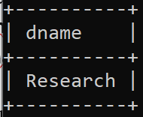

- Find the highest and the lowest salary of the male employees who are coming from the city where Suganthi comes.
SELECT Max(salary) as maximum_salary,MIN(salary) as minimum_salary from employee where gender = "male" and loc =(SELECT loc FROM employee where ename = "Suganthi");
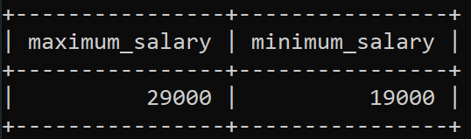

- Display the senior employee name who is working in the department where very young employee is working.
select ename as name from employee where doj=(select min(doj) from employee where dname=(select dname from employee where dob=(select max(dob) from employee)));
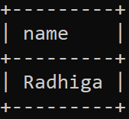

- For each department, retrieve the department name and the average salary of all the
employees working in that department where the department has more than two employees.
select dname,AVG(salary) from employee group by dname having count(dname)>2;
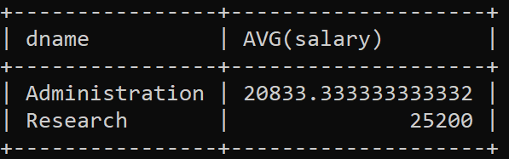

- Display the young female employee detail who is working in the department where the older employee is working.
select * from employee where dob=(select max(dob) from employee where gender='Female' and dname=(select dname from Employee where dob=(select min(dob) from employee)));
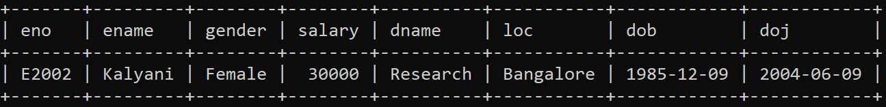

- At what age each employee gets job?
SELECT DATE_FORMAT(FROM_DAYS(DATEDIFF(CURRENT_DATE,doj)),'%y Years %m Months %d Days') as AGE from employee;
